Name: ___________________________________ Reg. No. _______________________
Ser. No. | Problem Statement | C++ Code
1 | Write code to display:  10  20  30  40  50  60  Using a while loop. | 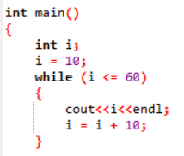  }
2 | Ask user to enter any five integer values. Write a while loop to calculate the sum of the entered values and display. | 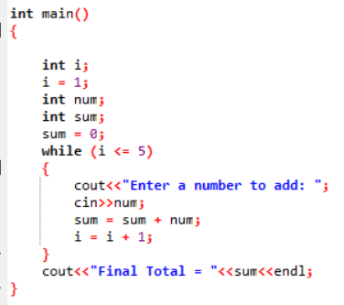
3 | Write output of the given code:  int main()  {  int count, total;  count = 1;  total = 1;  while (count <= 10)  {  total = total + count;  count++;  cout<<count<<endl;  }  cout << "My Answer is = ";  cout << total << endl;  return 0;  } | 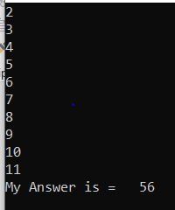
Just write the main function. Declare all required variables in your main () function

